**Signs and Symptoms of acute bacterial meningitis**

|  |  |
| --- | --- |
| Symptoms | Signs |
| * Headache (early) * Leg pains * Cold hands and feet * Skin discolouration | * **Meningism** → neck stiffness, photophobia, headache * **Kernig’s sign** (pain and resistance on passive knee extension with flexed hip) * Reduced GCS or coma * Neurological → seizures, focal CNS signs * **Petechial rash** * Fever * Vomiting |

**Signs indicative of sepsis:** slow capillary refill, DIC, hypotension, tachycardia and abnormal temp

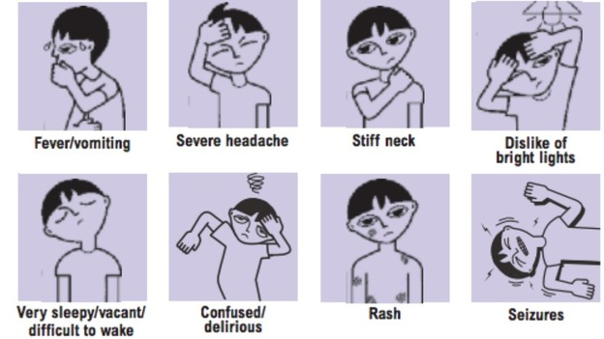

**Performing a lumbar puncture**

1. **Gain consent**
   * Indication → **suspected meningitis** or **SAH** with **normal CT**
   * Procedure → lying **left lateral position,** keeping very still, **local anaesthetic**
     + Once LA infiltrate there should be no pain, but there **may be some abnormal ‘shooting’ sensations in the legs**
   * **Risks/complications**
     + **Headache** → common (25%) 3-8 days post-procedure due **to low CSF pressure**. Response to **simple analgesia** and **lying supine**, although may require additional intervention if persists
     + Severe side effects are rare → **epidural bleeding**, **trauma to nerve roots** or spinal cord resulting in temporary or permanent nerve damage
2. **Procedure**
   * Mark site → L3/4 (level **with iliac crests**)
   * **Sterilise** → Wash hands, glove and gown. Drape patient with sterile towels and sterilise the area with iodine solutions
   * Local anaesthesia → **1% lignocaine**
   * Insert **22G spinal needle** → ensure you are exactly in the midline. Feel for the resistance of the spinal ligaments and epidural covering before entering the subarachnoid space. Then withdraw the needle and wait for CSF to appear. Measure pressure with a **manometer** (5-20cm H2O)
   * Collect **5 bottles of CSF** → 3 for microbiology, 1 for virology and 1 to biochemistry
3. Afterwards → through **documentation and prescribe simple analgesia**

**Management**

* **= NOTIFIABLE DISEASE** 
  + All cases of suspected meningococcal or Hib meningitis should be urgently reported to the local public health measures
  + **Chemoprophylaxis: household contacts/ mouth to mouth contacts 🡪 Ciprofloxacin + meningococcal vaccination (when serotype results are available)**
* **Start antibiotics immediately**
* Take blood cultures + blood in EDTA + Throat swab
* **Cefotaxime (or Ceftriaxone if aged 3 months – 50 years)**
  + **+Aciclovir IV 10mg/kg 8hrly** if viral encephalitis suspected
  + **+Amoxicillin IV 2g 4hrly** if immunocompromised, <3 months or >50 to cover for listeria (+gentamicin if listeria)
* **IV Dexamethasone** to reduce risk of neurological sequelae
* **Chloramphenicol** if allergic to penicillin/cephalosporins

**Emergency Investigations**

* **LUMBAR PUNCTURE** 
  + Contraindicated in: signs of raised ICP i.e. reduced consciousness, papilloedema, trauma, middle ear pathology or focal neurological signs. **CT required to exclude posterior fossa lesions** – take blood culture for these individuals instead
  + Also **contraindicated where there is coagulopathy**
  + CSF analysed for: culture, cell count, protein, glucose, antigen detection, PCR (viral)

|  |  |  |  |
| --- | --- | --- | --- |
| CSF | Bacterial | Tuberculous | Viral (asepctic) |
| Appearance | Turbid | Fibrin webs | Clear |
| Cell type | Polymorphs | Mononuclear | Mononuclear |
| Cell count (mm3) | 90-1000 (or greater) | 10-1000 | 50-1000 |
| Glucose | < ½ plasma | < ½ plasma | > ½ plasma |
| Protein (g/l) | >1.5 | 1-5 | <1 |
| Bacteria | In smear and culture | Often non in smear | None seen or culture |

**FBC** (Neutrophilia) , **U&E** (hyponatraemia), **Coagulation studies** (DIC), **CRP, Blood glucose** (to compare to CSF glucose) **Cultures 🡪** blood, throat swabs and rectal swabs  **Imaging 🡪** CXR and head XR may identify sources of sepsis

**Prognosis**

* **10% mortality in adults** (worse for strep or listeria. Worse if septic)
* **Morbidity 🡪 variable.** If the treatment is prompt outcome is usually excellent
  + **15%** develop severe sequelea including hearing loss, motor problems, seizures, mental retardation and hydrocephalus
  + **20%** more subtle deficits including cognitive, academic and behavioural problems

Routine vaccinations cover some pneumococcal bacteria and Hib but not meningococcus **(Quadrivalent meningococcal vaccine is given routinely to adolescents or for those with complement deficiency, asplenia or HIV)**

**Differential For Fever and Acute Confusion**

1. Infection
   * Intra-cranial → **meningitis, encephalitis**
   * Extra-cranial → any **acute systemic infection**
2. GI → **appendicitis, acute diverticulitis**
3. Exogenous - **Alcohol withdrawal, Drug withdrawal**
4. Endocrine - **Thyrotoxicosis**

**Organisms responsible for bacterial meningitis**

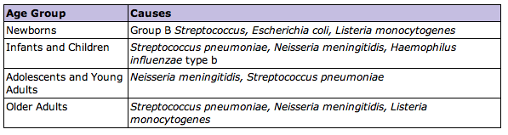

* **ALL age groups minus babies; Step Pneumoniae + Neisseria meningitides**
* **Babies susceptible to Group B strep**
* **Babies and Old people susceptible to Listeria monocytogenes**
* **Children susceptible to HiB**
* **TB** can also be seen in those that are immunocompromised
* **Trauma 🡪 staph**

(**LEG**)

**Herpes Simplex Encephalitis**

* Usually caused by HSV1 although in neonates HSV2 through delivery
  + Encephalitis Can also be caused by CMV, EBC, HIV, measles, mumps, rabies, TB, legionella, Lyme disease, Listeria, Leptospirosis, Malaria, cryptococcus, aspergillosus, connective tissue disease, vasculitis
* 2 peaks of presentation (neonates and adults >50
* **Clinical Features:** 
  + **Prodrome:** malaise, fever, headache, N&V, Lymphadenopathy
  + **Acute/subacute onset:** Reduced GCS, focal or generalised seizures, raised ICP (papilloedema), hemiparesis and cranial nerve lesions, bizzare behaviours, confusion and delirium, taste/smell hallucinations
* **Features in history or examination:** recent travel or animal bites, immunosuppression/HIV, cold sores
* **Investigations:** Bloods (including for Toxoplasmosis IgM) , Swab throat, MSU, Contrast enhanced CT (usually bitemporal involvement) – look also for meninges enhancement, LP, EEG (may show diffuse abnormalities) – treat within 30mins of arrival

(**NHS**)

**Huntingtons Disease**

* **Autosomal dominant neurodegenerative disorder caused by a CAG repeat within the huntington gene – degeneration of cholinergic and GABAergic neurones in the striatum of the basal ganglia (defect in chromosome 4)**
* **Clinical feature:**age 35 – 40 @onset, insidious then progressive signs, chorea 🡪 irritability 🡪 dementia 🡪fits 🡪 death
* **Neuropsychiatric symptoms:** personality changes, irritability, impulsiveness, dementia
* **Motor changes:** chorea, deficits in fine motor coordination, slowed saccadic eye movement

**Chorea, athetosis and dystonia**

* **Chorea**: irregular, random and variable movements which have a flowing or dancing quality which may appear semi purposeful

|  |  |
| --- | --- |
| **Acquired** | **Hereditary** |
| * **Post infectious** (**Sydenham’s chorea post rheumatic fever** – remember PECCS – polyarthritis, erythema marginatum, carditis, chorea, subcutaneous nodules) * **Polycythaemia rubra vera (JAK2, pruritis, splenomegaly etc)** * **SLE** * **Thyrotoxicosis** * **Drugs** → L-DOPA, phenytoin, neuroleptics | **Huntington’s disease**  A number of rare, inherited disorders |

* **Athetosis:** slower and more writhing in quality than chorea. It represents transition from one dystonic posture to another. It is typically associated with **congenital brain damage** (cerebral palsy). The **hands and feet** are typically affected
* **Dystonia:** involuntary, sustained,painful muscle contractions resulting in **abnormal posture.** Often caused by antipsychotic medications: classified as generalised or focal
  + **Focal:**
    - **Blepharospasm:** involuntary eye closure
    - **Oculogyric crisis:** eye rolled upwards (seen in post-encephalitic parkinsonism)
    - **Spasmodic torticollis** 🡪 scm contraction may turn the head to one side or move it forward or backward
    - **Laryngospasm**
    - **Trismus**
    - **Writers cramp**