ONEDstrictlybusinessgrace@hotmail.co.uk

**Post MI**

**Dressers syndrome:** Tends to occur 2 – 6 weeks following an MI  
- Fever, pleuritic pain, pericardial effusion, increased ESR

**Left Ventricular Aneurysm:** Persistent ST elevation + LVF. Thrombus may form and increase risk of stroke

**Left ventricular free wall rupture:** cardiac tamponade then acute heart failure

**Acute mitral regurgitation:** most common with infero posterior infarction. Early to mid systolic murmur heard.

**Management of STEMI**

**MONARC + Gastric Protection (Lansoprazole) + Glucose management**

* Morphine, Oxygen (if O2 <90%), Nitrate (GTN), Aspirin 300mg, Reperfusion(thrombolysis/PCI), Clopidogrel/Ticagrelor 180mg STAT
* Metoclopramide good if patient sick
* PCI to be offered if presentation is within 12 hours of symptoms and PCI can be delivered within 120 minutes of time where fibrinolysis could be given
* UFH post PCI (UFH measured using APTT and reversed with Protamine)

**Post STEMI: AA BAD heart**

* ACE inhibitor (Ramipril)
* Atorvastatin 80mg
* Beta blocker (Bisoprolol)
* Aldosterone antagonists (Eplenerone) if signs of heart failure
* Diuretics if fluid overloaded (Furosemide)

High bleeding risk patients to consider Clopidogrel instead of Ticagrelor long term.

**Definition, Signs & Symptoms**

* **Includes:** NSTEMI, STEMI, Unstable Angina

**Symptoms**

* Central / left sided chest pain
* May radiate to the jaw or left arm
* Heavy pain / constricting
* Dyspnoea, sweating, N&V

**Investigations**

* ECG
  + **ST Elevation suggests complete occlusion of a coronary vessel** which results in a **persistent elevation or LBBB pattern**
    - **STEMI criteria on ECG** 
      * >2.5mm ST elevation in V2-3 in men under 40
      * >2mm ST elevation in V2-3 in men over 40
      * >1.5mm ST elevation in V2-3 in women
      * >1mm in ST elevation in other leads
      * New LBBB
  + Transient ST elevation is seen with coronary vasospasm or prinzmental angina
* Cardiac markers i.e. Troponin >14

**Left Bundle Branch Block:**

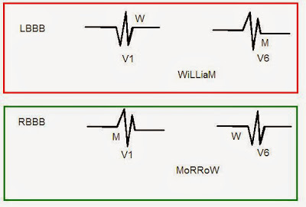

**Management of NSTEMI**

**MONARCH + Fondaparinux + Gastric Protection (Lansoprazole) + Glucose management**

* Morphine, Oxygen (if O2 <90%), Nitrate (GTN), Aspirin 300mg, Reperfusion(thrombolysis/PCI), Clopidogrel/Ticagrelor 180mg STAT, Fondaparinux until patient has undergone PCI
  + If patient is on DOAC or Warfarin with INR >2 – no need for Fondaparinux
  + If eGFR <20 Heparin
* Metoclopramide good if patient sick
* Calculate **GRACE score**
  + PCI immediately if unstable
  + PCI within 72 hours if GRACE score >3%

**Post STEMI: AAA BAD heart**

* Aspirin 75mg
* ACE inhibitor (Ramipril)
* Atorvastatin 80mg
* Beta blocker (Bisoprolol)
* Aldosterone antagonists (Eplenerone) if signs of heart failure
* Diuretics if fluid overloaded (Furosemide)

High bleeding risk patients to consider Clopidogrel instead of Ticagrelor long term.