**DKA**

* **Triggers (anything that stresses your body out)**
  + Interruption of **insulin therapy**
  + **Illness/stress**
  + **CATS drugs:** **C**orticosteroids, **A**ntipsychotics, **T**hiazide, **S**ympathomimetics (Dobutamine, Terbutaline)
  + **P**ancreatitis
  + MI or stroke, provoke GH, Cortisol/glucagon
  + Acromegaly
  + Cushing’s
  + Hyperthyroidism

**Management**

* **2 Large bore IV cannula**
* **CC UU GAF: CXR, Culture, VBG (**at **1, 2 and 4h)**
* **Fluids (NaCL 0.9% without Potassium)**
  + **1L in 15 minutes**
  + **1L in 1 hour**
  + **2L over the next 4 hours @500ml/hr**
    - **+40mmol Potassium (max 20mmol/hr)**
* **Insulin** 
  + **50U** in **50ml**
  + **0.1U/kg/hr NICE Guidelines**
    - **George’s: 6U 🡺 3U**
  + If BG not falling by **>3mmol/hr then inc. by 1U/hr**
  + **Make sure you are monitoring potassium**
  + Only give a STAT dose of ActRapid insulin if a delay of >1hr is anticipated in setting up an insulin infusion
  + Continue **long-acting SC insulin** – **glargine (Lantus)** or **detemir (Levimir)** if the patient was taking this before admission
  + **WITHOLD SHORT AND INTERMEDIATE ACTING INSULINS**
* If **Blood Glucose at presentation <14mmol/L** 
  + **10% Glucose @ 100ml/hr** and **reduce insulin to 3units/hr**
* **Aim to maintain BG in the range 9 – 14mmol/L**

**Diabetes Type 1**

* **Associations: TAP1 diabetes: Thyroid Autoimmune Pernicious Anaemia**
* **HLA DR3 +/- DR4**
* Seen in those Not breastfed/ Early cows milk introduction
* **T cell mediated destruction of beta cells of pancreas**

**Presentation**

* **Weight loss, Polydipsia, Polyuria**
* **DKA:** Abdominal pain, vomiting, drowsy, hyperglycaemia, ketonaemia, acid

Weakness, cold extremities, smell of acetone, kussmaul breathing, tachycardia, raised amylase, hypotension, hypothermia, leucocytosis

**Investigations**

* **U&Es, Urinalysis, Glucose, ABG, FBC**

**Management:**

* **Insulin** 
  + Normally **30 – 50U**
  + Basal-bolus insulin regimen = 1st line.
  + Intermittent rapid / short acting insulin injected with meals to control post prandial glucose
  + i.e.. **Insulin Glargine (Lantus) OD/ Insulin Detemir BD, Insulin Aspart (Novorapid) BEFORE** meals and snacks

**Diabetes Type 2**

**Aetiology**

* AGE, OBESITY, FAMILY, ETHNICITY
* **Maturity Onset Diabetes of the Young (MODY)**
  + Rare kind of type 2 diabetes
  + DOMINANTLY INHERITED
  + Easy to control
* **Syndrome X; metabolic Syndrome; Insulin Resistant Syndrome** 
  + **Increased BP, High blood sugar, excess body fat around the waist, abnormal cholesterol or triglyceride levels** occurring together increasing the risk of heart disease, stroke and diabetes.
  + Genetic susceptibility + Sedentary lifestyle + Central Obesity
  + Much greater risk of cardiovascular disease and diabetes
* Insulin resistance and relative secretory failure of insulin

**Presentation**

* **Polyuria, Polydipsia, Weight loss** 
  + **Polyuria differentials:** Overenthusiastic IV therapy, diabetes insipidus, inc. calcium, psychogenic polydipsia, polyuric phase of **recovering acute tubular necrosis**
* Lack of energy
* Genital inflammation
* Staphylococcal skin infections / abscess
* **Retinopathy (visual blurring):**
  + **4 Grades: PATH 4213: P**apilledema, **A**V nipping, **T**ortuisity & narrowing, **H**aemorrhages exudates and cotton wool spots
  + **Cataracts, Proliferative retinopathy, 3rd and 6th nerve palsy common.**
* **Polyneuropathy 🡪** stocking distribution, pes cavus, claw toes, isolated peripheral nerve lesions (immunosuppression may help i.e. corticosteroidsand IV immunoglobulins, painful muscle wasting, carpal tunnel, atonic bladder, gastroparesis, postural hypotension
* **Renal problems 🡪** 1st hypertrophy and raised GFR🡪Sclerosis🡪microalbuminuria🡪 Kimmelstiel Wilson Lesion – nodular / diffuse glomoreulosclerosis
* Erectile dysfunction
* Arterial disease; risk factor in the development of **atherosclerosis (Stroke & MI assoc.)**
* **Acanthosis Nigricans**

**Diagnosis**

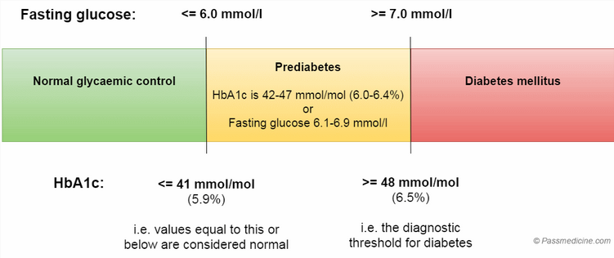

* **Symptoms of hyperglycaemia + Fasting Glucose >7**
* **2 Separate glucose levels >7 (if no symptoms)**
* **Impaired fasting glucose 🡪 due to hepatic insulin resistance**
* **Oral glucose tolerance test** used to diagnose diabetes in idividuals with **Impaired Glucose Tolerance** 
  + **>11 = Diabetes**
  + **7.8 – 11 = IGTT (**due to **muscle insulin resistance) – more likely to develop T2D**
* **Misleading HbA1c results due to increased red cell turnover**
  + Haemoglobinopathies
  + Haemolytic anaemia
  + Untreated iron deficiency anaemias
  + Suspected gestational diabetes
  + **Children**
  + **HIV, CKD**

* Monitor HbA1c every **3-6 months**  
* Target HbA1C **<48mmol(6.5%)**  
*Test at least **4 times day**   
* Glucose **target 5 – 7 on waking,   
4 – 7 before meals** & at other times of the day  
* Add Metformin if BMI >25

**Management of Type 2 Diabetes**

**Prevention of microvascular disease**

* **Diabetic eye: yearly measurements of acuity and photos of retina**
* **Diabetic kidney: aggressive treatment of BP with target below 130/80**
  + **Avoid Metformin and Glibenclamide**
* **Diabetic neuro:Duloxetine Amitryptilline, gabapentin, pregabalin**
  + **Tramadol** may be used as rescue therapy
  + **Topical capsaicin** may be used for localised neuropathic pain
  + **Codeine phosphate** if diarrhoea
  + **Anti-emetics/gastric pacing for gastroparesis**
  + **Fludrocortisone/Midodrine** for postural hypotension
* **Diabetic Foot (annually)** 
  + Look out for foot ulceration, cellulitis, abscess, osteomyelitis
  + Assess for charcot joint, test reflexes and sensation (10g monofilament)
  + Daily inspection, comfortable shows, chiropody

**Management**

* Stop smoking, lose weight
* **Calorie/carbohydrate restriction with increased physical activity –** tried for 3 months before commencing drug therapy
  + **High fibre, low glycaemic index sources of carbs, low fat dairy, oily fish, avoid them sugars and foods specifically marketed at diabetics**
* **Hypertension treatment –** target <140/80 or 130/80 if there is end-organ damage is present
* **Low dose aspirin**
* **ATORVASTATIN 20mg ONLY IF QRISK2 >10% (10 year cardiovascular risk) – consider titrating up if non-HDL has not fallen by >40%**
  + **Atorvastatin 80mg – secondary prevention of IHD, Cerebrovascular disease/ PAD**
* **MEDICATION** 
  + **First line = Metformin**
  + **Second line = Sulfonylureas (Gliclazide), Glptins, Pioglitazone**
  + **HbA1c** should be checked **every 3 – 6m** until stable then 6monthly
    - **Target <48mmol/mol (6.5%)** unless on drug which causes **hypoglycaemia (i.e. sulfonylurea)** then target is **53mmol/mol =7%**
  + **Insulin – continue Metformin** ; start with **NPH insulin (isophane, intermediate acting) taken @ bedtime / 2ce daily**
* HGV Licence / hypoglycaemic drugs 🡪 okay to drive as long as there has been no hypoglycaemic events in the last 1yr

**Hyperosmolar Hyperglycaemic Non Ketotic Coma (HONK)**

* **Absent Acidosis**
* **Osmolality >320mosmol/kg**
* **Occlusive events:** danger i.e. focal CNS sign, chorea, DIC, leg ischaemia/rhabdomyolysis
* **Rehydrate** with **0.9% saline IV infusion** over **48h (8 – 15L for a 70kg adult)**
* **Replace K+** when urine starts to flow
* Only **use insulin if blood glucose not falling by 5mmol/L/h** with rehydration or if ketonaemia
  + Start slowly at **0.05u/kg/hr** and **keep blood glucose at least 10 – 15mmol/L** for the first 24hours to **avoid cerebral oedema**
* Look for the cause i.e. **MI, Drugs or Bowel Infarct**

1st line if end stage renal failure

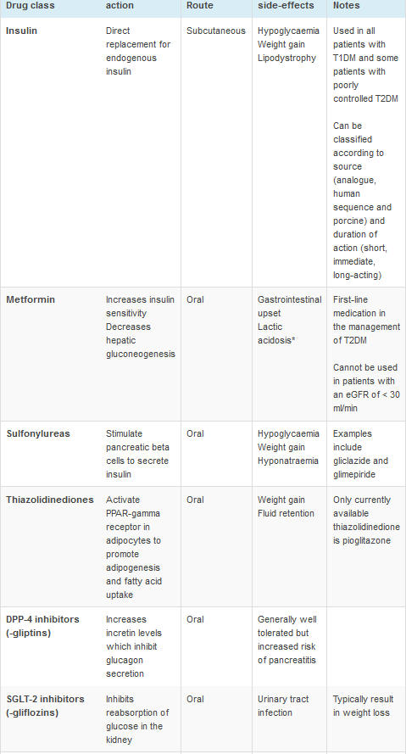

**Insulin**

* **Stimulates glucose uptake into the tissues**
* **Stimulates glycogen, lipid and protein synthesis**
* **Drives potassium into cells reducing serum K+ concentration**

**Types:**

* **Rapid acting** i.e. **Novorapid (Insulin Aspart)**
* **Short acting** i.e. **ActRapid**
* **Intermediate acting** i.e. **Humalin (Isophane)**
* **Long acting** i.e. **Glargine (lantus), Detemir (Levemir)**
* **Biphasic insulin prep** i.e. **Novomix 30 (insulin Aspart/Insulin aspart protamine)**

**Adverse effects**

* **Hypoglycaemia**
* **Weight gain**
* **Lipodystrophy**

**Interactions**

* In patients with renal impairment, insulin clearance is reduced 🡪 more likely to get hypoglycaemic
* Concurrent therapy with systemic corticosteroids 🡪 increased insulin requirements

**Medications**

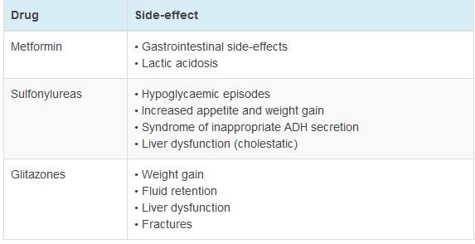

**Sulfonylureas are WHHAC (IDEs): Weight gain, Hypoglycaemia, Hyponatraemia, ADH(inappropriate), Cholestatic liver dysfunction**

**GliptIN – IncretIN increase – inhibits glucagon secretion (DPP-4)**

**SGLT2 – Flozin with my weight loss and my UTI**

**GLP1 Mimetic e.g. Exenatide (Option X = Last Resort)**

* If triple therapy is not effective/tolerated then **METFORMIN + SULFONYLUREA + GLP1**
  + **BMI >35kg/m2** and specific psychological or other medical problems associated with obesity
  + **BMI <35kg/m2** and for whom insulin therapy would have significant occupational implications
* **Weight loss** would benefit other significant obesity related comorbidities
  + Only continue if there is a **reduction of at least 11mmol (1%) HbA1c** and a weight loss of at least **3% of initial body weight in** **6 months**

