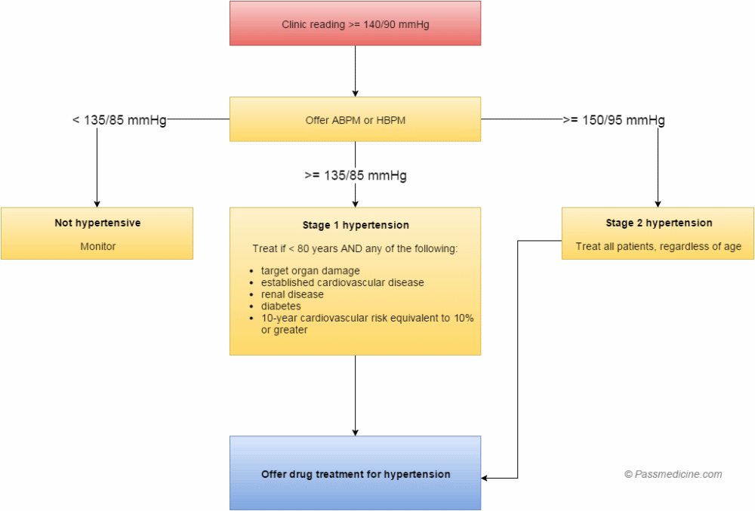
Diagnosis
Stage | Criteria
1 | Clinic BP >140/90 and subsequent ABPM daytime average or HBPM average BP >135/85
2 | Clinic BP >160/100 and subsequent ABPM daytime average or HBPM average BP >150/95
3 | Clinic BP >180/120  - Admit for specialist assessment if:  Signs of retinal haemorrhage / papilloedema / new onset confusion/ chest pain / signs of heart failure / AKI  - If none of the above, arrange urgent ECG, Bloods, Urine ACR and if target organ damage is identified, consider starting antihypertensives immediately without waiting for results of ABPM or HBPM

ABPM = 2 measurements per hour during the persons usual waking hours – average value of 14 measurements used
HBPM: 2 measurements BD for 7 days (discard readings on the first day)
Measure blood pressure in both arms
If difference in arms >20mmHg – subsequent blood pressures to be recorded from the arm with the higher reading
Causes of difference could include supravalvular aortic stenosis so investigate!
Blood pressure targets:
<80 – Clinic BP 140/90 & ABPM 135/85
>80 – Clinic BP 150/90 & ABPM 145/85
Indapamide (1.5mg modified release once daily or 2.5mg once daily) in preference to conventional thiazide diuretic
Secondary Causes
- Primary hyperaldosteronism inc Conn’s syndrome (most common cause of secondary hypertension)
- Glomerulonephritis
- Pyeonephritis
- Adult polycystic kidney disease
- Renal artery stenosis
- Phaeochromocytoma
- Cushings
- Liddles syndrome
- Congenital Adrenal Hyperplasia
- Acromegaly
- Steroids, MOAIs, COCP, NSAIDs, Leflunomide
- Pregnancy
- Coarctation of the aorta
Hypertension in Pregnancy
Diagnosis:
- >140/90
- Or increase above booking readings of >30/15
Women who are at high risk of developing pre-eclampsia should take Aspirin 75mg OD from 12 weeks until the birth of the baby i.e.
- Hypertensive disease during previous pregnancies
- Chronic Kidney Disease
- Autoimmune disorders such as SLE or Antiphospholipid syndrome
- Type 1 or 2 diabetes mellitus

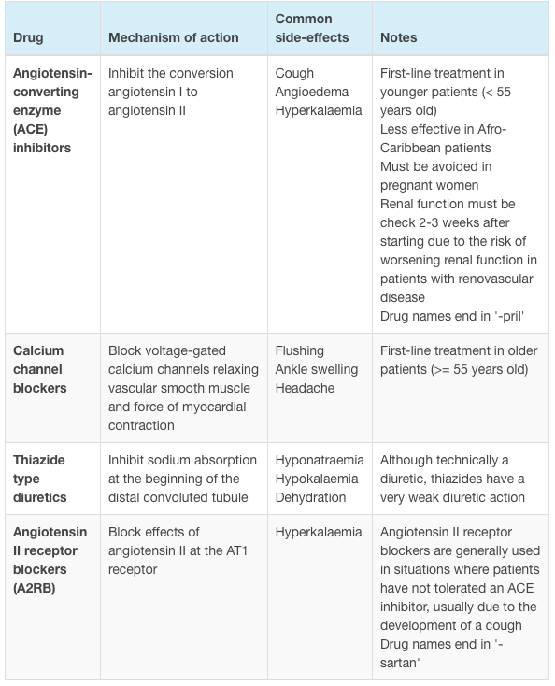
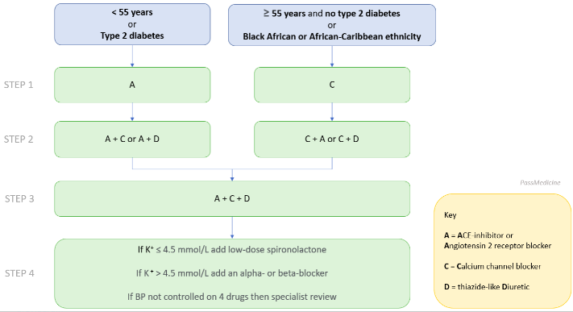

Management of Severe Hypertension
- Malignant HTN Vasoconstriction Renal ischaemia Renin and angiotensin II release Stimulation of RAAS secondary hyperaldosteronism hypokalaemia and metabolic alkalosis
- Slowly lower the blood pressure to safe levels (160/100) with initial fall in BP not exceeding 25% of the presenting value
  - (Exception is acute aortic dissection where systolic BP should be rapidly lowered to 100 – 120mmHg within 20 minutes)
- Malignant HTN – Nifedipine

Condition | Contra-indicated drugs | Indicated drugs
Aortic dissection | Vasodilators (on their own) | Metoprolol or Labetalol (± SNP), CCB
Hypertensive Encephalopathy | GTN, SNP, Centrally acting drugs | Labetalol
CVAs | GTN, Centrally acting drugs | Labetalol
ACS, MI | Short acting nifedipine | GTN, Metoprolol
Acute LVF | Caution with BB, labetalol, hydralazine | GTN, Diuretics, SNP
AKI | Caution with Diuretics | Labetalol
Malignant HTN | Caution with Diuretics | ACEi, BB, CCB
Cocaine | Beta blockers | Diltiazem

