**Hypothyroidism**

**Causes:**

* Treatment for hyperthyroidism, thyroid surgery, congenital disease, failure of the pituitary gland
* **Hashimotos =** Most Common = **DAP Associated**: Diabetes, Addison’s or pernicious anaemia
* **Subacute thyroiditis (de Quervain’s)** – associated with a **painful goitre + raised ESR**
* **Riedel Thyroiditis:** fibrous tissue replacing the normal thyroid parenchyma 🡪 **painless goitre**
* **Post partum thyroiditis**
* **Drugs: Lithium, amiodarone**
* **Iodine deficiency =** most common cause in the developing world

**Symptoms = Opposite of THYROIDISME + Hoarse voice**

* Cramps and weak
* Heart rate low
* Fatigued
* Lethargic/restless
* Menorrhagia
* Intolerance to cold
* Constipation
* Down mood
* Dry skin
* Myalgia and weight gain
* +Hoarse voice

**Signs = BRADYCARDIC**

* Bradycardia
* Reflexes relax slowly
* Ataxia (cerebellar)
* Dry thin hair/skin
* Yawning/drowsy/coma
* Cold hands (decreased temperature)
* Ascites and non pitting oedema
* Round puffy face/obese
* Defeated demeanour
* Immobile/ileus
* CCF
* +Neuropathy + Myopathy + Goitre

**Poor compliance with thyroxine – TSH high, T4 normal**

**Treat subclinical hypothyroidism IF:**

* **TSH >10**
* Thyroid autoantibodies positive
* Other autoimmune disorder
* Previous treatment of Grave’s disease

**Tx: Levothyroxine**

* Iron & Calcium Carbonate reduces the absorption of Levothyroxine SO need to give **4 hours apart.**

**Hyperthyroidism**

**Causes**: Excess iodine, **Grave’s disease (**autoimmune), hyperfunctioning thyroid nodules, thyroiditis, benign tumours of the thyroid or pituitary gland, tumours of the thyroid or pituitary gland, tumours of the ovaries /testes, drugs: amiodarone, Toxic multinodular goitre

**Symptoms (hyperTHYROIDISME)**

* **T**remor
* **H**eart rate up
* **Y**awning (fatigue)
* **R**estlessness
* **O**ligomenorrhoea/amenorrhoea
* **I**ntolerance to heat
* **D**iarrhoea
* **I**rritability
* **S**weating
* **M**uscle wasting/ weight loss (appetite)
* **E**xopthalmos

**Signs**

* Pulse fast/irregular
* Warm moist skin, Palmar erythema
* Fine tremor
* Thin hair
* Lid lag
* Lid retraction
* Goitre
* Thyroid nodules or bruit depending on the cause

**Signs of Grave’s**

* Eye disease, Exopthalmos, Opthalmoplegia (**STOP SMOKING) –** managed with **topical lubricants, steroids, radiotherapy, surgery**
* Pretibial myxoedema
* Odematous swellings above lateral malleoli
* Thyroid acropachy: Clubbing, painful finger and toe swelling, periosteal retraction in limb bones

**Investigations:**

* **TSH:** supressed, **Increased T4** & **T3**
* **Mild normocytic anaemia**
* **Mild neutropenia in Grave’s**
* **Increased ESR**
* **Increased Calcium**
* **Increased Liver Function Tests**
* **Check thyroid autoantibodies**
* **Isotope scan if the cause is unclear,** to detect nodular disease or subacute thyroiditis

**Management:**

* **Propranolol, Radioiodine treatment (avoid in pregnancy )**
* **Carbimazole 40mg (blocks thyroid peroxidase coupling and iodination of thyroglobulin)**
* **Surgery –** complications include **recurrent laryngeal nerve damage, bleeding, hypocalcaemia** (due to parathyroid gland damage)

**Thyroid Function Tests** 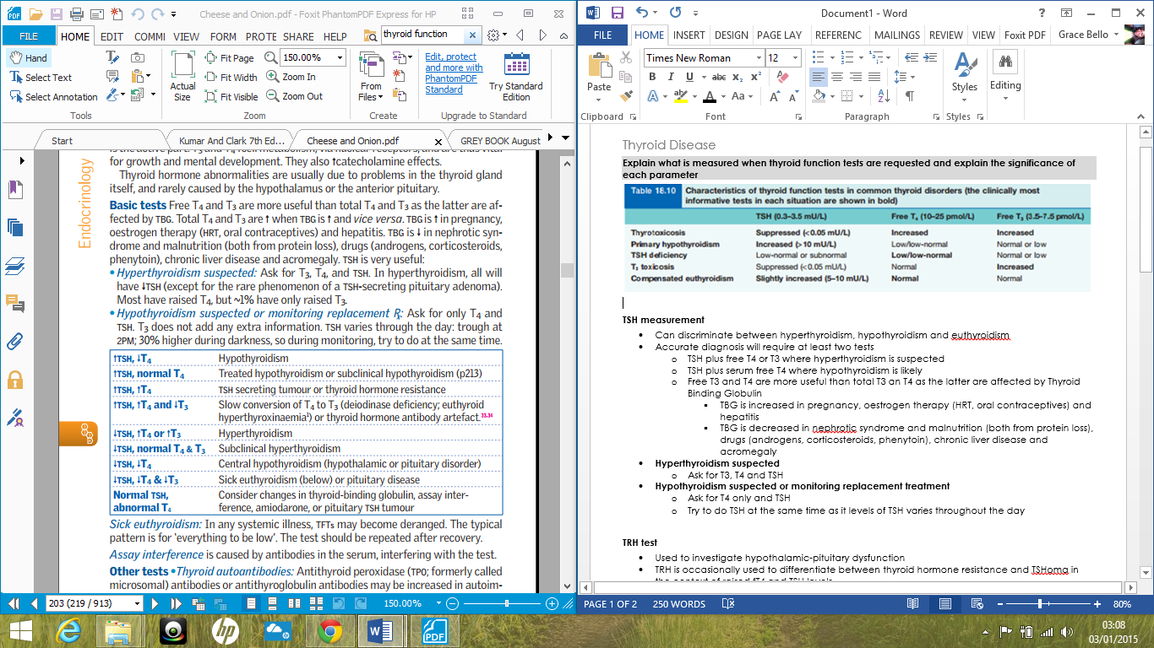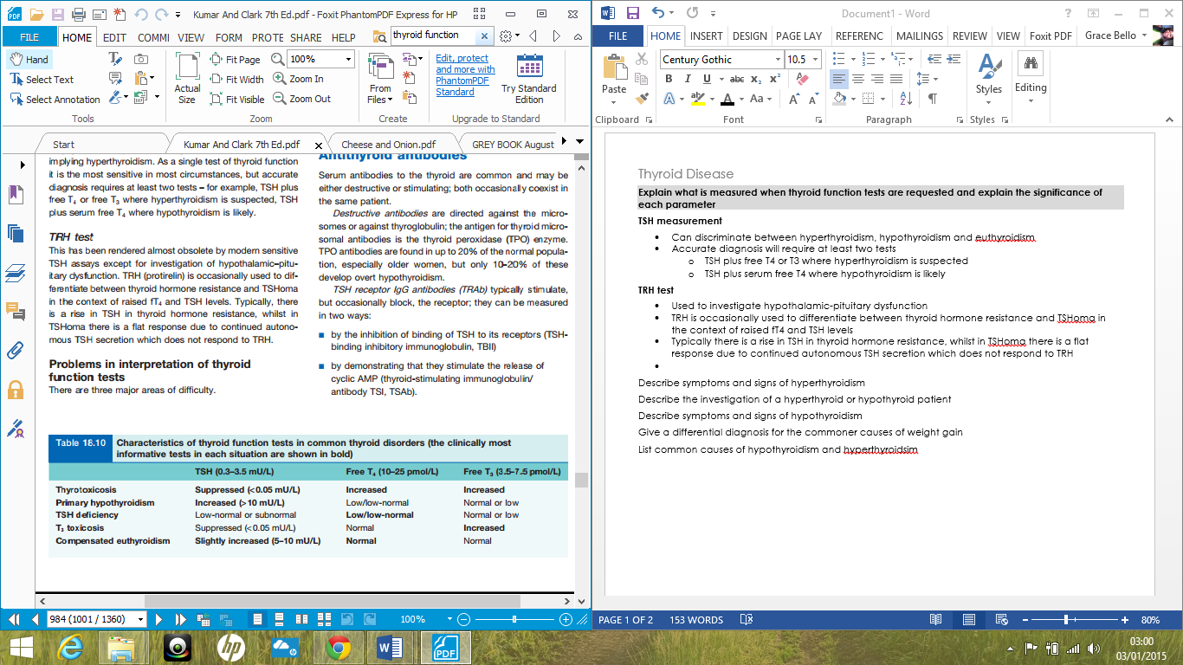

* **Free T3 and T4** are better than total T3 and T4 as the latter are affected by **Thyroid Binding Globulin** 
  + **TBG** is increased in pregnancy, oestrogen therapy and hepatitis
  + **TBG** is decreased in nephrotic syndrome, malnutrition, corticosteroids, phenytoin, chronic liver disease and acromegaly
* **Hyperthyroidism suspected** 
  + Ask for T3, T4 and TSH
* **Hypothyroidism suspected**
  + Ask for T4 only and TSH
  + Try to do TSH at the same time as its levels of TSH varies throughout the day
* **TRH Test**
  + Used to investigate hypothalamic-pituitary dysfunction
* **Systemic illness = Sick euthyroid**
* **Antithyroid peroxidase (TPO) antibodies / Antithyroglobulin antibodies** may be increased in **Hashimoto’s**
* **TSH receptor Autoantibodies** may be increased in **Grave’s Disease**
* **Serum thyroglobulin** 
  + Useful in monitoring the **treatment of carcinoma** and in detection of **self-medicated hyperthyroidism** where it is low
* **Ultrasound** 
  + Distinguishes cystic from solid nodules
  + If a solitary large nodule in a multinodular goitre, do a fine needle aspiration to look for thyroid cancer
* **Isotope scan** 
  + 123 iodine, 99 Technetium
    - Useful in determining the cause of hyperthyroidism and to detect retrosternal goitre, ectopic thyroid tissue or thyroid metastases (+whole body CT)
  + **20% of cold nodules are malignant (**few neutral and almost no hot nodules are malignant)
* **Surgery most likely to be needed if:** rapid growth, compression signs, dominant nodule on scintigraphy, nodule >3cm, hypoechogenicity