**Definition:**

Cardiac output is inadequate for the body’s requirements. It is the end stage of all heart diseases

* **Systolic failure** 
  + Inability of the heart to contract efficiently to eject adequate volumes of blood to meet the bodies metabolic demand
  + IHD, MI, Cardiomyopathy
* **Diastolic failure**
  + Reduction in the heart compliance resulting in compromised ventricular filling and therefore ejection
  + constrictive pericarditis, tamponade, restrictive cardiomyopathy, hypertension
* **Low output heart failure** 
  + **Pump failure**
    - Systolic and/or diastolic heart failure
    - decreased heart rate (e.g. B blockers, heart block, post MI)
    - negatively inotropic drugs (most anti-arrythmitic drugs)
  + **Excessive preload** 
    - Mitral regurgitation
    - Fluid overload (e.g. NSAID causing fluid retention)
      * Fluid overload may cause LVF in a normal heart if renal excretion is impaired or big volumes are involved (e.g. IVI running too fast)
    - More common if there is simultaneous compromise of cardiac function and in the elderly
  + **Chronic excess afterload**
    - Aortic stenosis, hypertension
* **High output heart failure** 
  + Heart failure that occurs in normal or high cardiac output due to metabolic demand and supply mismatch, either due to reduced blood oxygen carrying capacity (**anaemia**) or increase body metabolic demand (thyrotoxicosis)
  + Anaemia, pregnancy, hyperthyroidism, Paget’s disease, AV malformation, beri beri
* **Left Heart failure** 
  + Inability of the left ventricle to pump adequate amount of blood leading to **pulmonary circulation congestions and pulmonary oedema.**
  + Usually **results in right heart failure** due to **pulmonary hypertension**
* **Right Heart Failure** 
  + Inability of the right ventricle to pump adequate amount of blood leading to **systemic venous congestion**, therefore peripheral oedema and hepatic congestion and tenderness
  + Causes include l**eft ventricular failure, pulmonary stenosis, lung disease**
* **Congestive heart failure** 
  + Failure of **both right and left ventricles**, more common
  + Reserved for patients with **breathlessness and abnormal sodium and water retention** resulting in oedema
* **Acute heart failure** 
  + Onset of symptom presentation usually due to **acute event i.e. MI**
  + **decompensation of chronic heart failure** characterised by pulmonary and/or peripheral oedema with or *without signs of peripheral hypoperfusion*
* **Chronic heart failure** 
  + Slow symptoms presentation usually due to slow progressive underlying disease
  + **Venous congestion is common** but arterial pressure is well maintained until very late
* **Acute on chronic** 
  + Acute deterioration of a chronic condition usually following an acute event (anaemia, infections etc.)

**Risk Factors**

* Old age, male, obesity, alcohol, smoking
* Family history of heart failure
* MI, Hypertension, Left ventricular dysfunction, valvular heart disease
* Renal insufficiency
* Sleep Apnoea
* Diabetes mellitus, Dyslipidaemia
* Cocaine Abuse, cardiotoxic agents
* Elevated CRP, homocysteine, TNFa and IL6, natriuteric peptides
* Decreased iGF-1

**Differentials**

* Ageing / Physical inactivity
* COPD/Pulmonary fibrosis
* Pneumonia
* PE
* Post partum cardiomyopathy
* Cirrhosis
* Nephrotic Syndrome
* Pericardial disease
* Venous stasis
* DVT

**Causes**

* Coronary artery disease
* Ischaemic heart disease
  + Myocardial ischaemia, myocardial infarction
* Hypertension
  + Heart gets big 🡪 increased chance of arrhythmias 🡪 heart to big for coronary system to perfuse 🡪 iHD 🡪 compromised ventricular function
* Valvular disease
  + Mitral regurgitation (volume overload)
  + Aortic stenosis (pressure overload)
  + Tricuspid regurgitation (volume overload)
  + VSD/ASD (volume overload
* Pericardial disease
  + Pericarditis / Pericardial effusion
* Drugs
  + Alcohol: acute heart failure, arrhythmias and dilated cardiomyopathy
  + Cocaine
  + Chemotherapeutic drugs (beta blockers)
* Infection
* Infiltrative diseases
  + Amyloidosis, haemochromatosis, sarcoid
* Electrolyte imbalance
  + Hypocalcaemia, hypophosphataemia, hypokalaemia, hyponatraemia
* Endocrine disorders
  + Diabetes mellitus, thyroid disease, hypoparathyroidism with hypocalcaemia
  + Phaeochromocytoma, acromegaly
* Systemic collagen vascular diseases
  + Lupus, rheumatoid arthritis, systemic sclerosis, polyarteritis, hypersensitivity vasculitis, Takayasu syndrome, polymyositis, Reiters syndrome
* Drug induced
  + Adriamycin
  + Cyclophosphamide
  + Sulphonamide
  + Some antiviral agents
* Nutritional deficiencies
  + Thiamine, protein, selenium, L-Carnitine
* Myocarditis
  + Thyrotoxicosis/myxoedema
  + Arrhythmias
    - Bradycardia
    - Tachycardia
      * Reduced ventricular filling duration ; increased heart oxygen demand ; ventricular dilation
  + Atrio-ventricular mismatch due to atrial or ventricular arrhythmia
* **Cardiomyopathies** (diseases of the heart muscle not secondary to IHD, hypertension, valvular, congenital or pericardial disease)
  + **Congestive Dilated** 
    - Weakening and dilation of ventricular walls leading to overstretching, therefore reduced contractile efficiency
    - Most common cause of HF in the absence of IHD, valvular disease and hypertension
    - May have a familial risk
  + **Hypertrophic** 
    - Thickening of the heart muscle wall leading to reduced compliance and therefore reduced cardiac output
    - Thickening increases the chance of arrhythmias
  + **Restrictive** 
    - Reduced heart compliance without significant increase in muscle wall thickness leading to reduced end diastolic volume and cardiac output
    - This can be caused by infiltrative diseases such as sarcoidosis, amyloidosis, haemochromatosis and endocardial fibrosis
* Severe anaemia
* Pulmonary hypertension/pathologies
* Pregnancy

**Clinical Features**

|  |  |
| --- | --- |
| **Left Ventricular Failure (PCs DEFO WiN)** | **Right Ventricular Failure (RV POPed FATHERS)** |
| Paroxysmal nocturnal dyspnoea | Pulmonary oedema |
| Cough (Nocturnal) | Peripheral oedema |
| Cold peripheries | Facial engorgement |
| Dyspnoea | Anorexia |
| Excersice tolerance is poor | Tricuspid regurgitation |
| Fatigue | Hepatic tenderness |
| Orthopnoea | Epistaxis |
| Weight Loss / Wasting of muscles | RVF |
| Nocturia | Sickness (Nausea) |

**Framingham Criteria ; 2 major criteria/1 major criteria in conjunction with 2 minor criteria**

**Major Criteria: SAW PANIC**

* **S3 Gallop** (indicates the presence of congestive heart failure)
  + sudden deceleration of blood flow into the left ventricle from the left atrium
* **Acute pulmonary oedema/neck vein distension**
* **Weight loss more than 4.5kg in 5 days when treated** (patients lose their retained fluids)
* **Paroxysmal nocturnal dyspnoea**
* **Abdominojugular reflux** (JVP waveform rises when pressure is applied over the liver area)
* 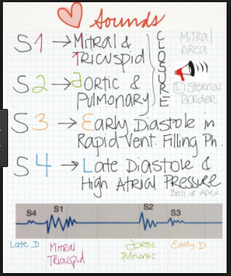**Neck vein distended** (i.e. JVP elevated at rest)
* **Increased cardiac shadow on the X ray (Cardiomegaly)**
* **Crackles on inhalation (rales)**

**Minor Criteria: HEART ViNo**

* **Hepatomegaly**
* **Effusion (pleural)**
* **Ankle oedema bilaterally**
* **exeRtional dyspnoea**
* **Tachycardia (>120bpm)**
* **Vital capacity decreased by a third or maximum volume**
* **Nocturnal cough**

Other symptoms include:

* Exhaustion, cool peripheries, cyanosis, decreased BP, narrow pulse pressure, pulsus alternans, displaced apex, right ventricular heave, murmurs of mitral or aortic valve disease, wheeze (cardiac asthma)

**Classification according to the New York Heart Association**

* **Class 1:** no limitation of life activities
* **Class 2:** slight limitation of moderate exercise, comfortable at rest but ordinary activity results in fatigue, palpitations or dyspnoea
* **Class 3:** moderate symptoms, marked limitation of physical activity; comfortable at rest but less than ordinary activity results in symptoms
* **Class 4:** severe symptoms; unable to carry out any physical activity without discomfort ; symptoms of heart failure are present even at rest

**Pathophysiology**

**MAP = CO X TPR**

**CO = SV X HR**

**SV = EDV – ESV**

* Heart failure causes a **drop in mean arterial pressure** that initially stimulates the baroreceptors that feedback into the medullary cardiovascular center (MCVC)
* MCVC tries to increase and maintain the MAP by **reducing vagal tone** leading to increased heart rate and therefore output
* The sympathetic system also stimulates the contraction of arteries (increased TPR) and veins (**increased venous return**) and the release of adrenaline from the adrenal medulla which stimulates all of the above actions
* **Renin-angiotensin-system** is also stimulated in heart failure due to **reduced kidney perfusion** caused by **reduced MAP** and vasoconstriction and direct sympathetic stimulation
  + **Angiotensin** II causes vasoconstriction, aldosterone release and ADH release causing Na and water retention by the kidneys
* These mechanisms are beneficial initially as they increase blood volume, therefore venous return and SV, TPR and heart rate 🡪 maintain a high CO
  + **Chronically these compensatory mechanisms act to worsen the situation** 
    - **Increase TPR**
      * Increase afterload therefore increasing workload and strain on the heart
      * Tissue underperfusion leading to ischemia
      * RAS system stimulation
    - **Increase HR**
      * Increase workload and therefore oxygen demand of the heart
    - **Fluid**[retention](http://almostadoctor.co.uk/content/systems/urology/urinary-retention)
      * Increase stretching of the heart eventually leading to dilatation of ventricles which possess reduced contractility
      * Fluid build up causes fluid transudation into interstitial tissue causing peripheral and pulmonary edema
      * Hyponatremia and hypokalemia
* **Complications of heart failure** 
  + Muscle **underperfusion** causing **muscle weakness** and **atrophy** causing **fatigue, exercise intolerance and dyspnea**
  + Increased risk of **thromboembolism** and **stroke development** due to **blood stasis, arrhythmias**  and **existing atheromas**
  + **Arrhytmias** 
    - Tightly associated with heart failure and responsible for a large proportion of death in patients with heart failure
    - **Atrial fibrillation** is the most common atrial arrhythmia that co-exists with HF and is associated with an increased risk of thromboembolism and stroke development
  + Ventricular tachycardia is common in advanced heart failure
    - Beta blocker treatments are used to minimise these vt
  + Increased risk of infections that can initiate an acute on chronic event

**Investigation**

* Choice of investigation is determined by whether the patient has previously had a myocardial infarction or not
  + **Previous myocardial infarction** 
    - Arrange an **echocardiogram within 2 weeks**
  + **No previous myocardial infarction** 
    - Measure **serum natriuretic peptides (BNP)** 
      * If the levels are high, arrange an **echocardiogram within 2 weeks**
      * If levels are raised arrange an **echocardiogram within 6 weeks**
  + **BNP Actions:** Vasodilation, Diuretic and Natriuretic, Suppress sympathetic tone and RAAS

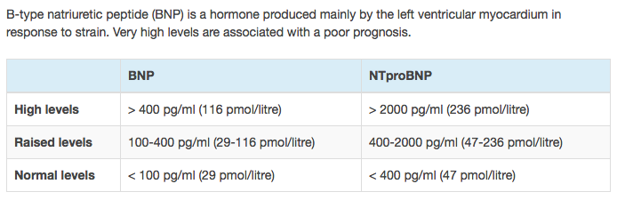

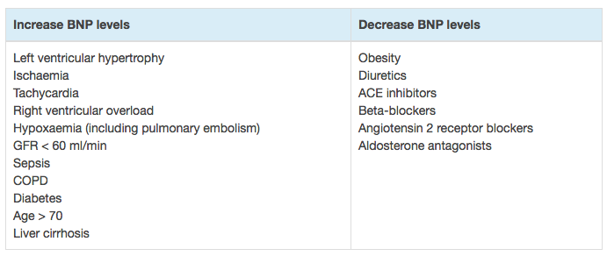

* **FBC, U&E**
  + **Anaemia** and **high lymphocyte percentage** are strong risk factors and prognostic markers of poor survival
  + Serum electrolytes (including calcium and magnesium)
    - **Decreased sodium** (usually<135mmols/L)- due to dilution
    - Altered potassium
    - Important to record baseline values
  + **Serum creatinine, blood urea nitrogen** 
    - Reflects tissue perfusion, fluid status and rules out renal disease
    - Normal to elevated
  + **Blood lipids** are decreased in end stage heart failure, especially in the presence of cardiac cachexia
* **Liver function tests** detect the extent of liver congestion/damage
* **Thyroid function tests** to rule out thyrotoxicosis or myxedema
* **Chest X ray** would show cardiomegaly, prominent upper lobe veins (upper lobe diversion), peribronchial cuffing, diffuse interstitial or alveolar shadowing, classical perihilar bats wing shadowing, fluid in the fissures, pleural effusions, septal (kerley B) lines, and engorged peripheral lymphatics



* + **ABCDE**
    - Alveolar oedema (bats wings)
    - Kerley B lines (interstitial oedema)
    - Cardiomegaly
    - Dilated prominent upper lobe vessels
    - Pleural Effusion
* **Endomyocardial biopsy** is rarely needed
* **Right heart catheterisation** 
  + Provides objective haemodynamic assessment of left ventricular filling pressure
  + Gives direct measures of cardiac output and pulmonary and systemic resistance

**Management of Chronic Heart Failure**

* **Conservative** 
  + **Stop smoking , eat less salt, optimise weight and nutrition** 
    - * Sodium intake between 2 and 3 g
  + Treat the cause
  + Treat exacerbating factors (anaemia, thyroid disease, infection, increased BP)
  + Avoid exacerbating factors (e.g. NSAIDs – fluid retention and verapamil – negative inotropic
* **Medical Management: (A BAD Virgin)**
  + - **ACE inhibitors (Enalapril, Lisinopril, Captopril) (first line):** consider in all those with left ventricular systolic dysfunction; improves symptoms and prolongs life; reduces afterload and fluid retention therefore slowing down left ventricular disease progression
      * **SIDE EFFECTS:** Cough; where this is a problem, an **angiotensin receptor blocker may be substituted (candesartan)**
      * **CAUTION:** in patients in cardiogenic shock, with marginal renal output or hyperkalaemia
    - **Beta blockers**: e.g. **carvedilol / Bisoprolol (first line)**decrease mortality in heart failure; benefits appear to be additional to those of ACE inhibitors in patients with heart failure
      * Often **given once established on an ACE inhibitor** unless there is a **contra-indication such as:**
        + **Bradycardia, reactive airway disease and unstable or low output**
      * Also considered in
        + **Sinus rhythm patients** that remains symptomatic even after full pharmacological interventions
        + Patients with **severely impaired left ventricular function**
        + Recurrent **hospital admissions**
    - **Aldosterone antagonists (second line):** decrease the morbidity and mortality associated with symptomatic chronic heart failure. Should be used in **early post-MI patients** with **left ventricular dysfunction** and/or moderate to severe heart failure. Should be initiated after titration of standard medical therapy
      * **Spironolactone & Eplerenone** can both cause hyperkalaemia. Precautions should be taken to minimise the risk. These agents should be used with caution in patients with renal dysfunction and hyperkalaemia
    - **Diuretics**: commonly loop diuretics e.g. **furosemide** 40mg/24hrs orally OR **bumetanide**1-2mg/24hrs orally
      * Produces symptomatic benefits more rapidly than any other drug for heart failure
      * Can relieve pulmonary or peripheral oedema within hours or days
      * Diuretics are not a good long term solution
      * Risk of clinical decompensation reduced when combined with an ACE inhibitor or a beta blocker
      * SIDE EFFECTS**: hypokalaemia** (To treat this, add a K sparing diuretic **spironolactone if K+ <3.2mmol/L**), predisposition to arrhythmias, concurrent digoxin therapy
    - **Vasodilators:** the combination of **hydrazaline** (**SE: drug induced lupus**) and **isosorbide dinitrate** should be **used if intolerant of ACE inhibitors and angiotensin receptor blockers** as it reduces mortality. It also reduces mortality when added to standard therapy in black patients with heart failure
      * Reasonable for patients with reduced left ventricular ejection fraction who are already taking an ACE inhibitor and beta blocker for symptomatic heart failure and who have persistent symptoms
      * May improve exercise tolerance in patients who have persistent limitations
      * Development of nitrate tolerance seems to be minimised by the prescription of a **nitrate free interval of at least 10 hours**
      * Carvedilol has been shown to prevent nitrate tolerance in patients with congestive heart failure
    - **Digoxin**: helps symptoms even in those with sinus rhythm; should be considered in patients with left ventricular systolic dysfunction who have signs or symptoms of heart failure whilst receiving standard therapy (**for persisting symptoms**). **Especially good with those whom have atrial fibrillation** 
      * **Ivabradine** is an alternative; criteria to start this drugs:
        + Patient is already on **ACE inhibitor, beta blocker + Aldosterone antagonist +** has a heart rate of >75/min and left ventricular fraction <35%
    - Offer **annual influenza vaccine**
    - Offer **one of pneumococcal vaccine**
    - **Amiodarone** in arrhythmic patients
* **Intractable heart failure** 
  + **Reassess the cause**
  + Are they taking drugs at the maximum dose
  + Switching furosemide to bumetanide (one 5mg tablet = 200mg furosemide) may be better for absorption
  + Consider admitting for strict bed rest and Sodium & fluid restriction
  + Metolazone (thiazide) (as above)
  + Opiates and IV nitrates may relieve symptoms
  + Weigh daily
  + Do frequent U&E (beware of hypokalaemia)
  + Give DVT prophylaxis: heparin + TED stockings
  + Cardiac transplant
  + Revascularisation in ischaemic heart disease (CABG or Angioplasty)
  + Valvular replacement
  + Implanted automatic cardio defibrillator or pacemaker

**Management of Acute Exacerbation (Grey Book)**

* **Acute decompensated heart failure** is a life threatening condition with a 30 day mortality of 15% in those with **NT ProBNP >5000ng/L** and 5% in those with **NT ProBNP <5000NG/l**
* Patients with heart failure should generally be discharged from hospital only when their clinical condition is stable and the management plan is optimised
* **Community heart failure nurse follow up** reduces the **3 month risk of readmission** by **35%**
* If heart failure is suspected request a **serum NT-proBNP** and **U+E Sample**
* If the **NTproBNP** is normal (**<300**), search for an alternative diagnosis
* 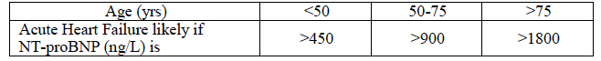If **NTproBNP** concentration is intermediate (above 300ng/L but below acute heart failure levels), reconsider the diagnosis
  + If after full reassessment, heart failure is likely, request an echocardiogram
* **Heart Failure Echo Requests** 
  + NT-proBNP level must be documented on the request form
  + Repeat echo is not necessary if there is an **echo within the last 6 months** unless there has been a change in clinical condition or a new lesion (e.g. a new murmur) is suspected
* **Acute pulmonary oedema** 
  + Call the cardiology SpR ; arrange admission to CCU
  + **O2** to maintain SaO2 (95 – 98%)
  + **IV furosemide 40 – 80mg bolus** followed by an **infusion @ 5-20mg/hr if required**
  + Consider **IV GTN infusion** (10 – 200micrograms/min) for patients with concomitant myocardial ischaemia, severe hypertension or regurgitant aortic or mitral valve disease
  + Maintain systolic **BP >100mmHg** and monitor in a level 2 area
  + **CPAP** (with mechanical ventilation for respiratory failure, physical exhaustion and if appropriate for the patient)
  + **Monitor:** 
    - **Pulse, Oximetry and BP** every 5 – 10 minutes with **continuous ECG**
    - Request Chest X-ray
    - FBC, plasma U&Es, creatinine, NT-proBNP, TFTs, LFTs, troponin, glucose and lipids, arterial blood gases if oxygen saturation is low or oxygen is required to maintain saturation
  + **Review Medication** 
    - **Stop calcium channel blockers and NSAIDs where possible**
    - In unstable patients with diabetes, switch to insulin sliding scale
    - Patients already on **ACE and/or beta blockers**; efforts should be made to **maintain usual medication doses** even if the first doses need to be omitted to to hypotension
      * Withdrawal of beta blockers in acute heart failure patients has been shown to be associated with increased mortality risk
    - If patient presents in **fast atrial fibrillation** and **pulmonary oedema**, consider **digoxin initially** until Beta blockers can be initiated and up titrated

**Other Relevant LOBs**

**Starlings Curve**

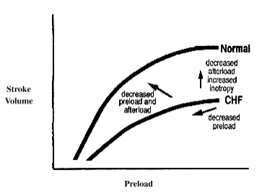

* **Starlings Law of the Heart: The stroke volume of the heart increases in response to an increase in the volume of blood filling the heart (the end diastolic volume) when all other factors remain constant**
* The increased volume of blood stretches the ventricular wall,, causing cardiac muscle to contract more forcefully
* The stroke volume may also increase as a result of greater contractility of the cardiac muscle during exercise, independent of the end diastolic volume
* The Starling mechanism appears to make its greatest contribution to increasing stroke volume at **lower work rates**and contractility has its greatest influence at higher work rates
* In the failing heart, the more the myocardium is dilated, the weaker it can pump as it then reverts to laplace law
* **Systolic failure**
* Where there is impaired left ventricular contractility
* The ability to increase stroke volume via an increase in preload is diminished and the curve shifts to the left of the normal curve if inotropy and afterload remain constant
* As left ventricular failure worsens cardiac volumes and pressures continue to increase leading to pulmonary venous congestion. If this process is allowed to continue, increased pulmonary venous pressure leads to right ventricular hypertension, failure and increased central venous pressures.

**State Starling’s Principles of capillary fluid exchange and use it to explain the formation of oedema in cardiac failure**

* The starling equation illustrates the role of hydrostatic and oncotic forces in the movement of fluid across capillary membranes



* *P*c is the capillary [hydrostatic pressure](http://en.wikipedia.org/wiki/Hydrostatic_pressure)
* *P*i is the interstitial hydrostatic pressure
* *π*c is the capillary [oncotic pressure](http://en.wikipedia.org/wiki/Oncotic_pressure)
* *π*i is the interstitial oncotic pressure
* *K*f is the filtration coefficient – a proportionality constant
* *σ* is the reflection coefficient
* Outward force is defined as positive and inward force is defined as negative
* Oedema is an abnormal accumulation of fluid in the interstitium located beneath the skin and in the cavities of the body
* A **rise in hydrostatic pressure**occurs in cardiac failure – this is the cause of oedema
* Pulmonary oedema occurs when the pressure in blood vessels in the lung is raised because of obstruction to the removal of blood via the pulmonary veins. This is usually due to the failure of the left ventricle

**Laplace Law**

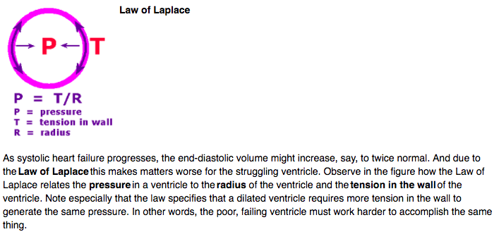

**Interpreting a Chest X ray (PIER ABCDEFGHI)**

#### Assessment of quality

The quality of the image can be assessed using the mnemonic PIER:

* position: is this a supine AP file? PA? Lateral?
* inspiration: count the posterior ribs. You should see 10 to 11 ribs with a good inspiratory effect
* exposure: well-exposed films have good lung detail and an outline of the spinal column
* rotation: the space between the medial clavicle and the margin of the adjacent vertebrae should be roughly equal on each other; look for indwelling lines or objects

#### Bones and soft tissues

Scan the bones for symmetry, fractures, osteoporosis, or metastatic lesions. Evaluate the soft tissues for foreign bodies, oedema, or subcutaneous air.

#### Cardiac

Evaluate the heart size: the heart should be [<50% of the chest diameter on PA films](https://radiopaedia.org/articles/cardiothoracic-ratio) and <60% on AP films. Check for the heart shape, calcifications, and prosthetic valves.

#### Diaphragms

Check diaphragms for the position (the right is slightly higher than the left due to the liver) and shape (may be flat in [asthma](https://radiopaedia.org/articles/asthma-1) or [COPD](https://radiopaedia.org/articles/chronic-obstructive-pulmonary-disease-1)). Look below the diaphragms for free air.

#### Effusions

[Pleural effusions](https://radiopaedia.org/articles/pleural-effusion) may be large and obvious or small and subtle. Always check the costophrenic angles for sharpness (blunted angles may indicate small effusions). Check a lateral film for small posterior effusions.

#### Fields and fissures

Check lung fields for infiltrates (interstitial vs. alveolar), masses, consolidation, [air bronchograms](https://radiopaedia.org/articles/air-bronchogram), [pneumothoraces](https://radiopaedia.org/articles/pneumothorax" \o "Pneumothoraces), and vascular markings. Vessels should taper and should be almost invisible at the lung periphery.

Evaluate the major and minor fissures for thickening or fluid.

#### Great vessels

Check aortic size and shape and the outlines of pulmonary vessels. The [aortic knob](https://radiopaedia.org/articles/aortic-arch) should be clearly seen.

#### Hila and mediastinum

Evaluate the hila for lymphadenopathy, calcifications, and masses. The left hilum is normally higher than the right. Check for widening of the mediastinum (which may indicate [aortic dissection](https://radiopaedia.org/articles/aortic-dissection)) and tracheal deviation (which may indicate a mass effect or tension [pneumothorax](https://radiopaedia.org/articles/pneumothorax)). In children, be careful not to mistake the [thymus](https://radiopaedia.org/articles/thymus) for a mass!

#### Impression

In most cases an impression is worth while as it not only forces you to synthesise all the findings together but acts as double check.