**UPPER LIMB**

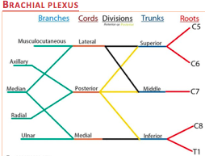

**Upper Plexus Lesion (C5,C6)**

* Traction on the arm at birth – **Erb’s palsy (waiter’s tip)**
* Falling on the shoulder i.e. motor cyclists
* Deltoid, supraspinatus, infraspinatus, biceps, brachialis = paralysed.

**Posterior Cord lesion (C5,C8)**

* Deltoid, extension of elbow, extension of wrist, extension of fingers

**Lower Plexus lesion (C8-T1)**

* **Klumpke Palsy** i.e. forced abduction of the arm at birth/trauma – grabbing something to break a fall
* **claw hand, horners syndrome (if T1 is involved)** 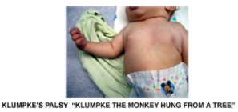

**Total brachial lesion** = complete flaccid paralysis and anaesthesia of the arm, Horner’s symptoms

**Brachial Neuritis**

* Associated with viral infection (EBV/CMV)
* Vaccination (tetanus, flu)
* Strenuous exercise
* **Acute onset** with **preceding shoulder pain**
* **Proximal weakness**
* Occasionally bilateral
* Treatment with narcotics / steroids

**Axillary**

* **Motor:** abduction (deltoid, teres minor, triceps brachi)
* **Sensory:** regiments patch
* **Pathology occurs where:** 
  + Anterior dislocation of the humerus at the glenohumeral joint or a fracture of the humerus at the surgical head
  + **Unable to abduct the affected limb (deltoid and teres paralysis)**
  + Paralysed deltoid rapidly atrophies and the greater tuberosity can be palpated in that area

**Musculocutaneous**

* **Motor:** Flexion at the elbow (brachialis, biceps, coracobrachialis)
* **Sensory:** C6 Dermatome
* Flexion at the elbow is weak but can still occur
* Supination is weak
* Flexion at the shoulder is weak
* Sensation loss on lateral side of the forearm

**Median nerve**

* From the **medial and lateral cords**
* Crosses medial to the brachial artery, travels between the **flexor digitorum profundus and superficialis** and enters hand via the **carpal tunnel** where it innervates the **thenar muscles, skin of palm and lateral 2 lumbricals (1ST and 2nd finger)**
* **Motor:** flexion at the wrist (flexors), thumb abduction, pronation of the forearm (median rotates the thumb medially = pronation)
* **Sensory**
* **Damage:** 
  + Carpal tunnel syndrome
    - Entrapment at wrist due to synovial sheath thickening 🡪 fluid retention (pregnancy, weight gain), rheumatoid, acromegaly, hypothyroidism
  + **Clinical Features (LOAF muscles)**
    - Pain especially at night, paraesthesia (eased by shaking or dangling it out the bed), cutaneous sensory loss, wasting and weakness of the thenar muscles
      * Unable to oppose thumbs (Apes hand)
    - Tinel’s and Phalen’s positive
    - **Pointing 1st – 3rd finger** at elbow level median nerve damage (hand of benediction)
      * **DEFICIT MORE PROMINENT WHEN THE PATIENT IS ASKED TO MAKE A FIST (FDP in lateral 2 digits – ulnar nerve)**
  + **Investigate:** nerve conduction studies showing slowing of conduction over the wrist
  + **Treat** the cause, wrist splinting, steroids and **surgical division** of the **transverse ligament** if symptoms fail to improve

**Radial Nerve**

* **Motor:** extension at the elbow (triceps brachii), extension at the wrist
* **Sensory:**

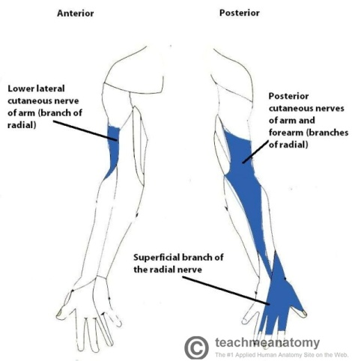

* **Damage:** 
  + In the axilla = disclocation of the humerus at the glenohumeral joint/ fracture of the proximal humerus, IM injection, badly fitting crutch ‘**Saturday night palsy’**
  + In the radial groove – midshaft fracture of the humerus
  + Deep branch – found in the forearm – damaged by fracture of the radial head or posterior radial head dislocations
* **Symptoms** 
  + loss of sensation over anatomical snuffbox
  + Wrist and finger drop

**Ulnar Nerve**

* Enters through Guyons canal superficial to the flexor reticulum
* **Motor: Flexor Carpi Ulnaris** and **Flexor digitorum profundus** (3rd and 4th lumbricals at MCP), palmar and dorsal interossei, hypothenar muscles (opponens digiti minimi, flexor digiti minimi brevis and abductor digiti minimi), adductor pollicis (all intrinsic muscles of the hand except **LOAF**)
* Froment’s sign – weak pincer grip (may try to compensate with median nerve FPB)
* **Sensory**

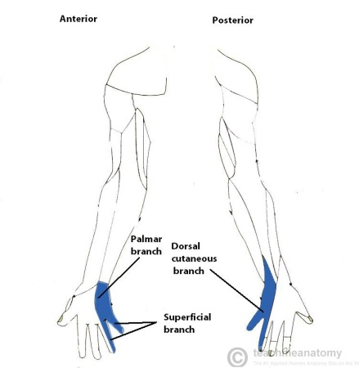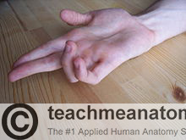

* **Damage:** injury to elbow (dislocation), entrapment at the elbow, pressure at palm of hands
  + **Damage at elbow** 
    - Weakness in flexion of the hand at the wrist, loss of flexion of ulnar half of digits and loss
    - **CLAW HAND PRESENT AT REST** due to hyperextension of the 4th and 5th digits @ MCP joints and flexion of the interphalangeal joints
    - Weakness of thumb adduction
  + **Damage at the wrist** 
    - **Claw hand deformity is more prominent with injury**
    - **Radial deviation @wrist**
  + **Guyon’s canal syndrome –** sensation at the back of the hand is normal, wasting and paralysis of hypothenar muscles
  + Lack of index and middle finger flexion when you ask the patient to make a fist
  + Unable to adduct or abduct fingers



**Posterior Tibial (S1, S2)**

* Division of the sciatic nerve in the popliteal fossa and descend behind the tibia terminating in the medial and lateral plantar nerve 🡪 supply of the small muscles of the foot
* **Motor:** posterior compartment of the leg (**gastrocnemius)**
* **Sensory:** contributes to the **sural nerve**
* **Damage** 
  + Trauma in the popliteal fossa
  + Fracture of the tibia
  + Systemic causes of mononeuropathy
* Results in
  + Weakness of plantarflexion and inversion of the foot
  + Patient can not stand on their toes
  + Sensory loss over the sole of the foot
  + **Ankle reflex loss**
  + Tarsal tunnel symptoms
    - Where the posterior tibial nerve is entrapped below the medial malleolus – burning pain in the sole of the foot, weakness of toe flexion and atrophy of small muscles in advanced cases
* **Systemic causes of mononeuropathy** 
  + Diabetes mellitus
  + Hypothyroidism
  + Rheumatoid Arthirtis
  + Vitamin deficiencies
  + Vasculitis
  + Sarcoidosis
  + Amyloidosis

**LOWER LIMB**

**Lumbar plexus**

* Located in the psoas muscle. Important branches = femoral and obturator nerves
* L2-L4 = Femoral nerve emerging from lateral bornder of psoas and transverses below the inguinal ligament with the femoral artery
* **Damage**
  + Trauma following surgery (hysterectomy, labour)
  + Compression from an abdominal mass
  + Infiltration from pelvic tumour
  + Lumbosacral neuritis – infection
  + DM and vasculitis (bilateral)
* **Symptoms**
  + Pain / Burning – worse with coughing

**Sacral Plexus**

* Located in the posterior wall of the pelvis
* L4 - S2 = Common peroneal
* L4 – S3 = Tibial nerve
* Both fuse 🡪 sciatic

**Lateral Cutaneous Nerve of Thigh**

* Innervates the lateral part of the thigh (originating from the lumbar plexus (L2,3)
* Seen over the Sartorius
* **Damage = entrapment , meralgia parasthetica**
* Results from iatrogenic damage i.e. surgical procedures or from a neuroma
* Purely sensory
* Altered sensation over the anterolateral aspect of the thigh. **NO MUSCLE WEAKNESS**

**Common Peroneal / Fibular**

* **Motor** 
  + Short head of the biceps, wraps around the head of the fibular
  + Superficial nerve: lateral compartment of the leg (eversion)
  + Deep nerve: anterior compartment (dorsiflexion)
* **Sensory** 
  + 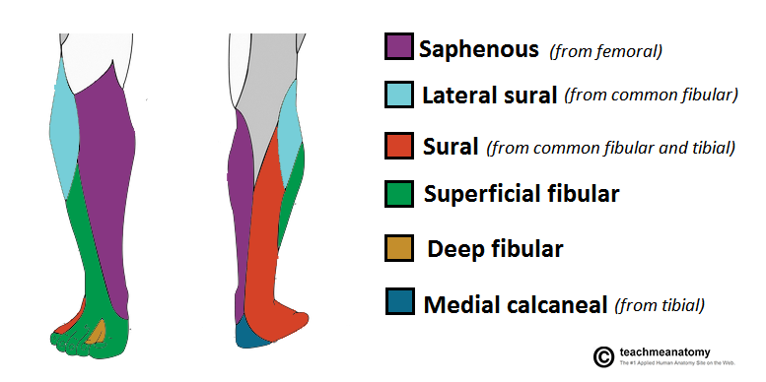
* **Damage:** trauma to head of fibula (kneeling, crossing legs, diabetes) – results in weakness in dorsiflexion and eversion of the foot – **foot drop ; sensory loss of dorsum and outer aspect of foot**

**Mononeuritis Multiplex**

* Presents with sensory and motor deficits in the distributions of specific peripheral nerves
* Often vasculitic in origin but may be caused by: RA, SLE, Sarcoidosis, DM, Infection, Malignant infiltration.

**Charcot Marie Tooth**

* Autosomal Dominant
* 60% have CMT1A (demyelinating)
* Onset in childhood/teens
* Slowly progressive **distal** symmetrical sensorimotor polyneuropathy
* **Distal wasting** is prominent
* **Pes Cavus**

**Investigations**

* **Nerve Conduction studies** can not pick up small fibre neuropathy (pain & temperature)
  + Demyelinating vs axonal pathology
    - Demyelinating: decreased nerve conduction velocity
    - Axonal: decreased action potential amplitude
* **Needle Electromyography (EMG)** 
  + Excludes myopathy and NMJ
  + Helps to confirm neuropathy
  + Helps to differentiate from anterior horn disease