**Inflammatory Myopathy**

*Due to an immune mediated process rather than directly pathogenic. Acquired as opposed to inherited. Includes Polymositis (childhood/adulthood), Dermatomyositis, inclusion body myositis*

**Polymyositis and Dermatomyositis**

* ONSET = acute or subacute over a period of several weeks – may follow systemic infection
* Systemic symptoms prevail at onset and are then followed by muscle weakness
* Extensive oedema of the skin and subcutaneous tissue (esp. periorbital region) is common
* **Dermatomyositis (B cell mediated often perivascular infiltration necrosis) –** unlike poly – T cell
  + Gottron’s Papules – roughened red papules over the extensor surfaces of the finger, Raynaud’s
  + Interstitial lung disease; fibrosing alveolitis or organising pneumonia
  + Can also get dysphagia and dysphonia
  + Treated with **STEROIDS, IV Ig**
  + **Polymyositis : usually Treated with Steroids / Azathioprine**

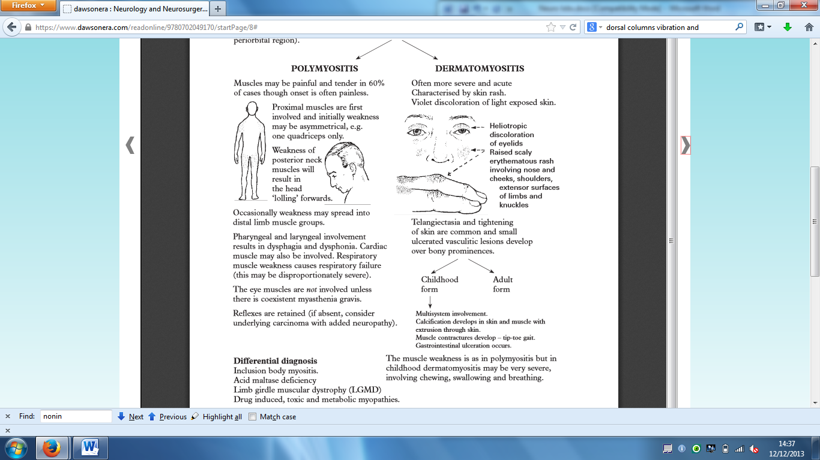

**inclusion body myositis**

* Commonest inflammatory muscle disorder in the middle aged and elderly (more likely = men)
* **asymmetrical distal weakness (and axial) =** painless and **distal** including foot extensors and finger flexors – may be associated with neuropathy ; inclusion bodies and necrosis seen in muscle biopsy
* Protracted course unaffected by immunosuppressive treatment

Investigations in any inflammatory myopathy: **CK, EMG, RF, ANA, ESR, Muscle Biopsy**

**Musclular Dystrophies**

*Genetically determined progressive disorders of the muscle cha*racterised by cycles of muscle fibre necrosis, regeneration, eventual fibrosis and replacement with fatty tissue

Genetics: implications for the family are clear, cardiac disease, respiratory failure

**Duchenne Dystrophy**

* **1 in 3500 male births; X linked ; frameshift mutation**
* **Clinical Features** 
  + Delayed early motor development usually notes **between ages 1 and 3** followed by **scoliosis, contractures** and **eventual loss of ambulatin** at around 12 years of age
  + **Pseudohypertrophy of muscle –** calf in particular is a characteristic feature (80%)
  + Child can not climb stairs or rise from a low chair and when attempting to rise from the ground will ‘climb up him’ 🡪 **Gower’s Sign** (indicative of pelvic muscle weakness
* **Investigation** 
  + Gene testing on the **dystrophin gene**
  + **CK** substantially elevated from birth
  + **ECG** shows conduction disorders **tall R waves**
  + **EMG** shows myopathic changes
* **Management** 
  + Surgery to collect scoliosis, active control of contractures, NIV**,** steroids slow progression
* **Prognosis** 
  + Death from respiratory insufficiency in late 20s / early 30s

**Becker Dystrophy**

* Milder condition than DMD but also involves **mutation of the dystrophin gene**
* **DEVELOPS AFTER THE AGE OF 10**
* Presents at a later age with **limb girdle involvement** and **pseudohypertrophy**
* Mild symptoms in carrier females BUT disease of males
* **Diagnosis:** DNA serum analysis in 80%, 20% will have muscle biopsy showing ***relative absence of dystrophin***, **CK elevation** seen in bloods

**Myotonic Dystrophy**

* **Autosomal Dominant Multisystem disorder ; Features develop 20 – 30 years**
* **DM1: CTG repeat at the end of the DMPK) gene on chromosome 19; DISTAL WEAKNESS** more prominent
* **DM2: caused by a repeat expansion of the ZNF9 gene on chromosome 3; PROXIMAL WEAKNESS** more prom.
* **Myotonia** (failure of immediate muscle relaxation after contraction has ceased)
* **Can also get:** 
  + Cataracts
  + Disorders of smooth muscle
    - Constipation
    - Poor bladder emptying
  + Dilated cardiomyopathy
  + AV block requiring cardiac pacing
  + Resp failure
  + Impaired swallowing
  + Diabetes due to insulin resistance
  + Testicular atrophy and subfertility
* **Diagnosis:** clinical 🡪 mild cases will need   
  genetic analysis

**TONE = RESISTANCE TO PASSIVE STRETCH  
UMN = HYPER // Cerebellar lesion and LMN: HYPO**

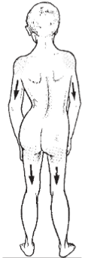

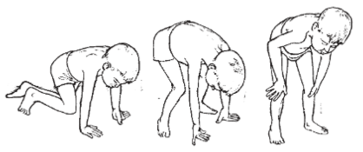

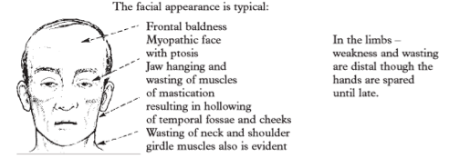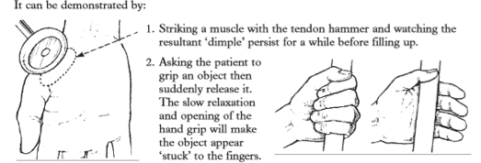

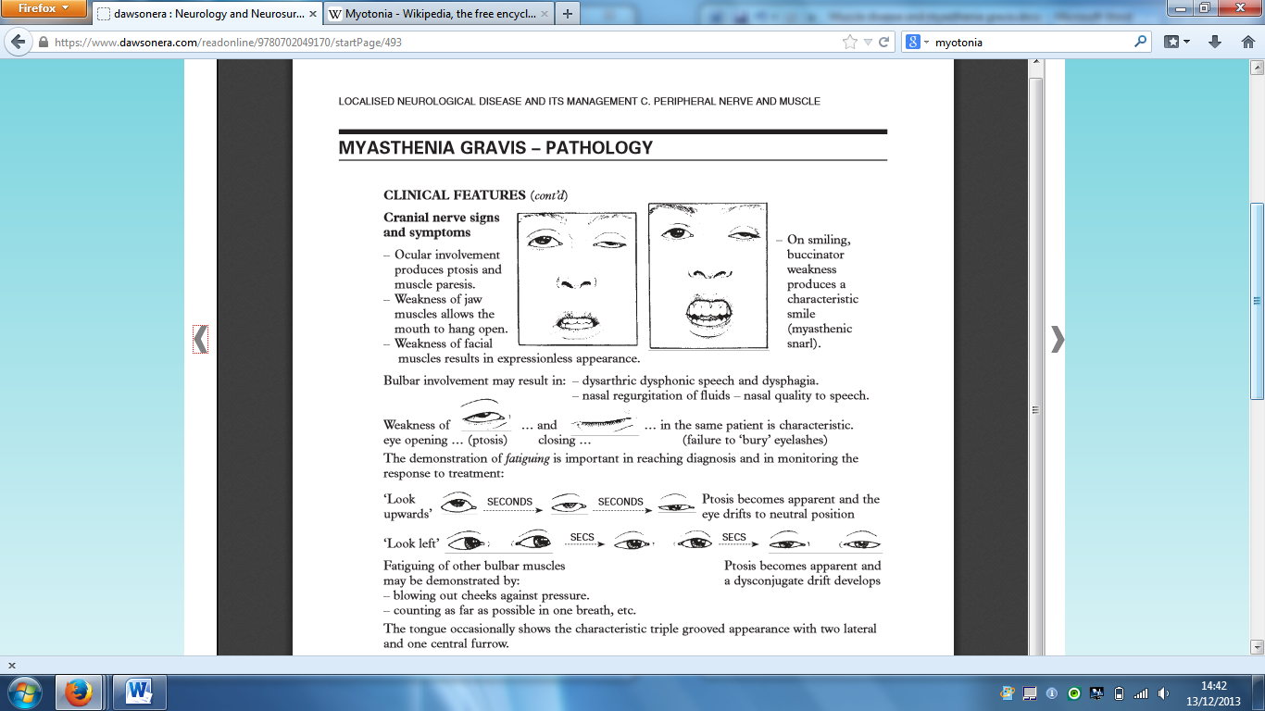

**Myaesthenia Gravis**

*Disorder of neuromuscular transmission characterised by weakness and fatigue in some or all of the muscle groups, weakness worsening on sustained or repeated exertion, or towards the end of the day 🡪 relieved by rest*

**Cause**

* **Autoimmune destruction of the nicotinic postsynaptic receptors for acetylcholine (AchR antibodies)** demonstrated by radioimmunoassay in the serum of 90% of patients
* **Thymic abnormalities** occur in 80% of patients
  + Main function of the thymus is to affect the **production of T cell lymphocytes** – thymus dysfunction is noted in a large number of disorders which may be associated with MG e.g. SLE
  + 20% have an involuted gland, 70% show hyperplasia with lymphoid follicles and germinal centres, 10% have a thymoma – encapsulate tumour of lymphoid and epithelial cells which may be locally invasive but rarely metastasises
* **Autoimmune disorders;** pernicious anaemia, autoimmune thyroid disorders, rheumatoid, SLE

**Clinical Features**

* **90% <40yo F:M 2:1**
  + **Class 1:** ocular muscles only
  + **Class 2:** mild generalised weakness
  + **Class 3:** moderate generalised and mild to moderate ocular bulbar weakness
  + **Class 4:** severe generalised and ocular bulbar weakness
  + **Class 5:** myaesthenic gravis 🡪 respiratory involvement
* Weakness of neck muscles = lolling of the head, proximal muscles = preferential

**Exacerbating Factors:**

* **EXERTION, PENICILLAMINE, QUINIDINE, PROCAINAMIDE, BETA BLOCKERS, LITHIUM, PHENYTOIN, GENTAMICIN, MACROLIDES, QUINOLONES, TETRACYCLINES**

**Investigations**

* **Single fibre electromyography:** high sensitivity (92 – 100%); reduced amplitude of the repetitive evoked potentials (**decrementing response**)
* **CT Thorax** to exclude thyoma
* **CK** normal
* Autoantibodies:
  + around 85 – 90% of patients have **antibodies to acetylcholine receptors** – magnitude of titre correlates with disease severity
  + 40% are positive for **anti-muscle-specific tyrosine kinase antibodies**
* **Tensilon test:** 
  + **IV Edrophonium (Anticholinesterase)** reduces muscle weakness temporarily (2-4mins) given with **Atropine**– not commonly used anymore due to the risk of cardiac arrhythmia

**Management**

* **Long acting anticholinesterase e.g. pyridostigmine (4HR ACTION):** Inhibition means more Ach available for NMJ transmission
  + **Large doses 🡪 Cholinergic Crisis 🡪 WORSENING WEAKNESS, SWEATING, SALIVA & BRONCHIAL SECRETIONS, SMALL PUPILS, RESP FAILURE**
* **Atropine (muscarinic inhibitor)** may be required to counter side effects (D&V, nausea, fasciculation, weakness)
* **Immunosuppression: prednisolone 60mg/day =** brief deterioration before improvements // **Azathioprine/cyclosporine** in non-responders
* **Thymectomy**

**Management of Myasthenic Crisis (When having a crisis, take a NAP – Neostigmine, Atropine, Prednisolone**)

* **INTUBATE AND VENTILATE**
* **IV Neostigmine 8-12mg/24h w Atropine 0.5mg TDS, Prednisolone 100mg OD**
* **Plasmapheresis / Intravenous immunoglobulins**

**Side Note:**

**Myaesthenia Gravis patients are sensitive to Rucuronium (non depolarising NDMA) but resistant to Suxamethonium which relies on binding to and activating receptor. In MG, few receptors to bind to!**

**Muscle Physiology**

* **Type 1:** slow twitch, fatigue resistant
* **Type 2:** fast twitch, fatigue dependent
* **Muscle contraction:** 
  + Depolarisation wave arrives at the axon terminus and opens voltage sensitive calcium channels 🡪 acetylcholine release 🡪 sodium channel opening (action potential in sarcolemma 🡪 release of calcium from the sarcoplasmic reticulum and interaction of actin and myosin 🡪 muscle contraction
  + Cholinesterase destroys Ach so that a single nerve impulse only gives rise to a single muscle contraction